Dear Sir/Madam,
Emperial Waste is delighted to submit our fumigation, disinfection, and pest services proposal for you.
Our mission is to ensure your highest satisfaction when it comes to maintaining a clean and pest-free environment.
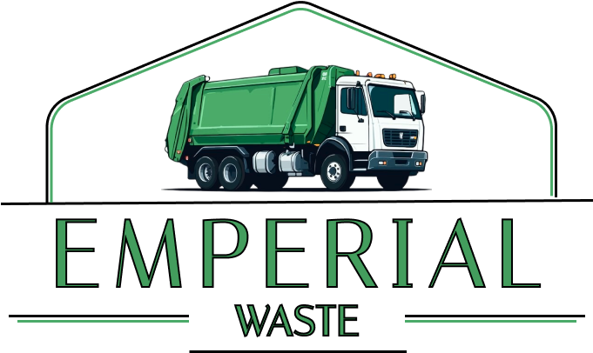
Our company has six years of experience providing professional fumigation, disinfection and pest control services. We have built a strong reputation in the industry and have been delivering reliable services since before breakout of corona virus. With us, you are assured of quality and confidence in our work.
Please do not hesitate to contact us if you have any inquiries about our services, pricing or payment terms. We also sell large skip containers for your efficient refuse management!
Contact us on:
050 479 3161
024 582 5120
050 175 4564
026 943 2505

We look forward to serving you!
Sincerely,
Emmanuel Ohemeng
Emperial Waste and Facilities Management

